Welcome Back To School!

Welcome back! I hope everyone has had a great Christmas break full of fun and rest. I also hope that you’re all now happily back into the school routine. Everyone at school, including myself, is excited for the term ahead.

Timetable
If you are wondering what a typical school day looks like for your child this term, our weekly timetable is below. History and geography alternate each term starting with history and next term we are doing geography. Also, as you can see, PE days are Mondays and Wednesdays so the children will need to wear their PE kits on these days.

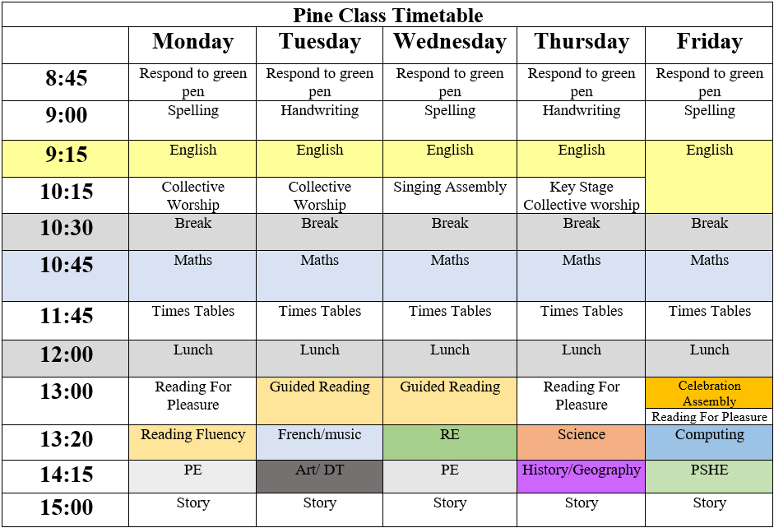

Home Learning reminders
Reading
It is so important for the children read as much as possible. It is massively beneficial for them. It helps them to not only improve their reading, but also their spelling and writing as well as their knowledge and understanding of the world. Therefore, as you can see in the timetable, the children read every day in school. It’s also strongly suggested that the children read every day at home, whether it be before or after school.

We understand that schedules can be busy and sometimes it’s difficult to fir this in. In Pine Class, if your child reads 4 or more times a week and it’s recorded in their reading record (Adult or child can write in this- date, pages read or how long they read for, and a comment about the book or the reading), they earn a book point. Book points collected can be spent in the book points book shop (exclusive to Pine Class) on books, stationary and some other little trinkets. The book points bookshop happens in term 2, 4 and 6.


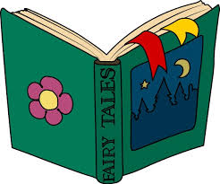

It is also important for children to be read to aloud by an adult at home. The reason for this is that it will encourage a love of reading.
Children can take reading books home from school to read. We do just ask that these books are looked after and ensured that they are returned to school when they’re finished with.

Times Tables
Times tables are an important aspect when the children get into KS2. They are tested on them at the end of year 4 but more important than this, knowing their times tables as early as possible will equip them with basic facts for other maths areas and will support the four operations.



Times Table Rock Stars is a free app that you can download onto smartphones and tablets. You can also just go onto the website. The children have logins. I will send the logins home with them too. It is a really fun and effective way to learn your times tables. I will be setting tournaments up on there as well to make it competitive and to motivate them.
Please ensure that your child practises their times tables for 15 minutes, 4 times a week or as much as possible. This could be on the iPad or alternatively, I can provide resources that don’t require a screen if you would prefer.

Spellings
I have been sending home spellings for the children to practise for spelling tests on Fridays. Please ensure these are being practised at home. They are all words from the statutory year 3 and 4 word list so the children need to be able to spell these before they leave Pine Class. On the sheets I send home, I have suggested strategies for how to practise.

Other
- It has been very cold recently and is going to continue to be cold for a while so please ensure your child brings in a coat for playtimes.
- Please ensure long hair is tied back to ensure safety and productivity.
- Please make sure that school uniform is correct and that jumpers have names on in case they are lost or accidentally picked up by the wrong person.

Thank you for your anticipated support. I always enjoy working with parents/carers so I look forward to continuing the learning journey with you all this year. If you’d like to speak with me outside of school hours regarding your child, please can I ask that you send me a message on the Pine Class email or contact the school office by telephone or email. Alternatively, feel free to catch me at the end of the school day for a chat. I can’t wait for the year ahead!

